
Social Media Event Resources from Virginia Headwaters Council
Virginia Headwaters Council will create an event page on Facebook up to four weeks before your event begins.
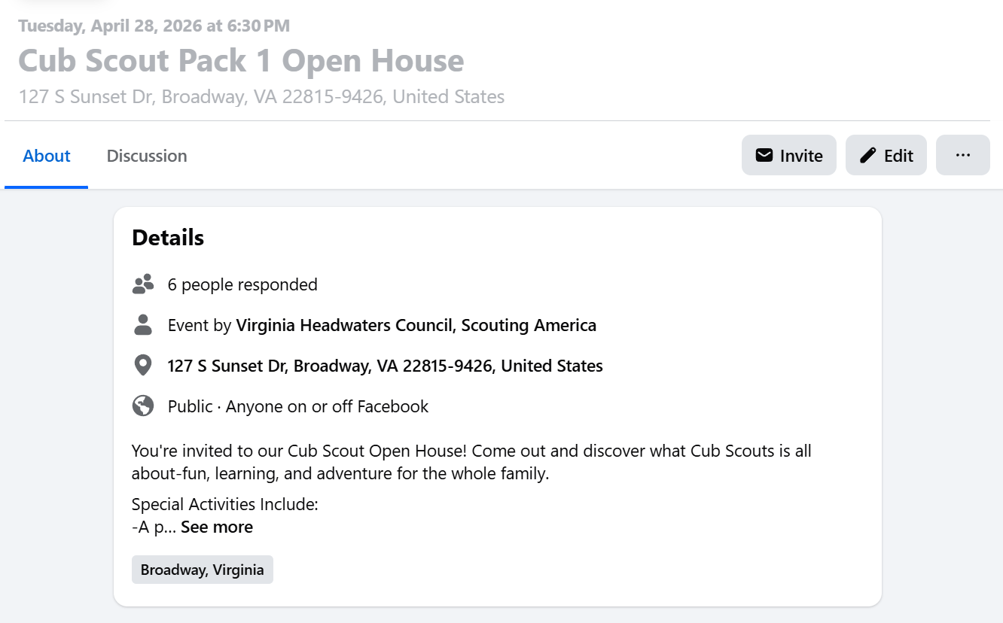
- Submit your event information as soon as you have it confirmed.
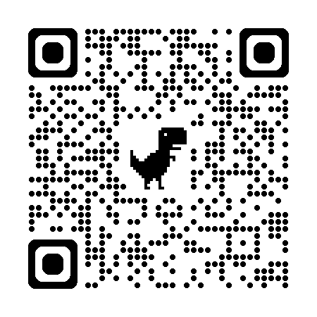
  - Submit Fall 2026 Information Here: https://forms.gle/BwetiVxRFFqBiKHe9
- If your unit has a Facebook page, you will be added as the “co-host” so that unit volunteers can interact with the event page.

- Event Page can be created up to four weeks prior to the event.
  - Share the event page on your units and families personal Facebook and Instagram pages.
  - Add the event page link to community list servs, PTA Newsletters, Social Media Groups, and Next Door.
  - Post fun updates in the discussion section of the event page to get interested families to engage.
- VAHC will pay for an event ad to run across Facebook and Instagram for ten days prior to your event.
  - Exact distance and budget for each ad will depend on your specific area, but the goal will be to get a critical number of eyes on your event.
